Name: Malaika Saleem

Class : AI C

Roll no. : 22i-0509

PROJECT REPORT OOP

This project consists of a system that asks the user whether they want to log in as a teacher or a student.

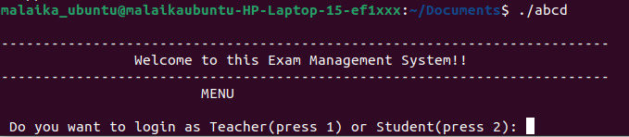

CASE 1(Student):

Upon selecting student the system asks for his or her roll no. and upon entering the roll no., the system checks for the validity of the roll no. put in. It does so by reading the file (Students.csv).

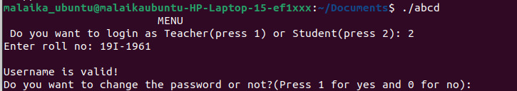

In case the ID entered is not present in the file it tells the user that the ID is invalid. If the roll no. is present in the file, it asks the user for the password. The password must contain at least six characters of which at least one should be one upper case, one number, one lower case, and one special character. For this purpose, the function of **getstudentpassword** () is called which asks the user if they want to change the password or not. If they select yes then they enter the previous password and the new password else they enter just the current password. We assume in both cases that the user knows the password, however, it must fulfill the mentioned requirements.The password is hidden by using **getpass**() built in function for privacy. If the password fulfills all requirements then the system displays the complete information of the student which includes the student’s roll no. , name, and the courses they are registered in.

. 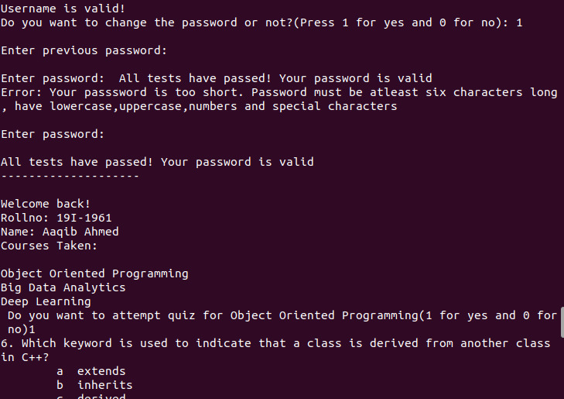

The program then asks the student if they want to attempt the quiz only if the quiz is made by the teacher. If the student selects yes then the student is presented with the quiz of the subject they chose. Then the program asks the user to enter the question no. along with the option, they think is correct.

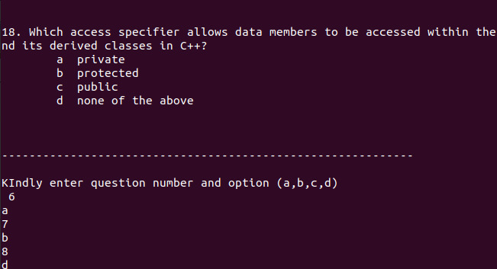

The system stores their answers in a separate file having csv extension. Then the answer of the student is compared with an answer key having .csv extension. For every correct answer, the marks of the student are increased by one and at the end the marks of the student are displayed.

The answers of the student:

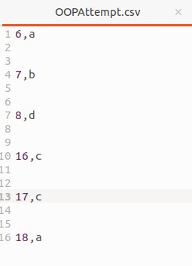

The answer key:

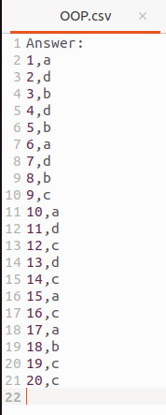

After quiz of 1 registered course is attempted. Then the system asks user if they want to attempt the quiz of another subject or not.

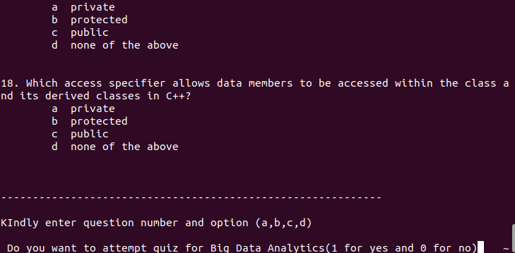

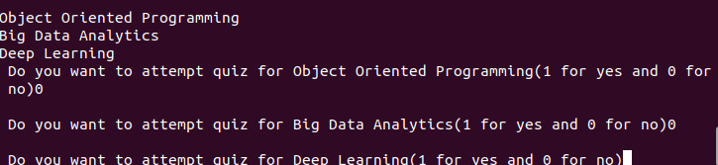

PROCESS BEHIND CASE 1(Student):

So the mechanism that happens in the .**cpp** file is that on choosing to login as a student a function **FindStudent()** is called which reads the **Student.csv** file and look for the entered roll no. in it. If it finds the roll no. in the file it tells that the roll no. is valid and calls the **getstudentpassword()** which checks the validity of password. If the password is valid it reads the **Student.csv** again and stores the detail(name, roll no, courses registered) and displays them. After this a new function **askforattempt(**) is called, which ask user if they want to attempt quiz. Upon entering yes it calls 2 functions 1. **displayquiz**() and 2. **attemptquiz**() . Both these functions are functions of **class Quiz**. **displayquiz**() displays the **Quiz.csv** file created by the teacher of that course. **attemptquiz**() function creates a .**csv** file and writes the answers of the user according to the course they chose.

CASE 2(Teacher):

Upon choosing a teacher the system asks for his or her ID and upon entering the ID the system checks for the validity of the ID put in. It does so by reading the file (Teachers.csv). In case the ID entered is not present in the file it tells the user that the ID is invalid. If the ID is present in the file, it asks the user for the password. The password must contain at least six characters of which at least one should be one upper case, one number, one lower case, and one special character. For this purpose, the function of **getteacherpassword** () is called which asks the user if they want to change the password or not. If they select yes then they enter the previous password and the new password else they enter just the current password. We assume in both cases that the user knows the password, however, it must fulfill the mentioned requirements. If the password fulfills all requirements then the system displays the complete information of the teacher which includes the teacher’s ID, name, and the courses they are currently teaching.

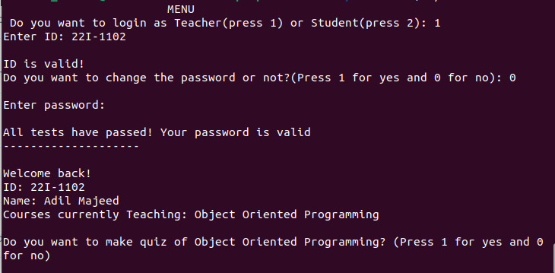

Then it asks the teacher if they want to make a quiz on their course or not. Upon selecting yes the system asks the teacher the no. of topics ( 1 to 4 ) and no. of questions from each topic ( 1 to 5 ) they want to make the quiz from.

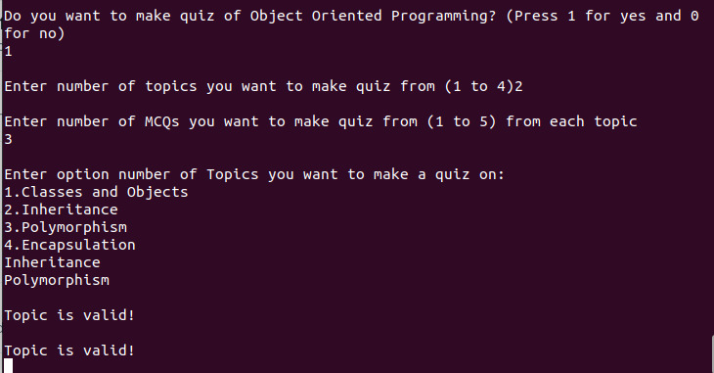

Upon entering the numbers the system makes a quiz in form of separate .csv file having those questions.

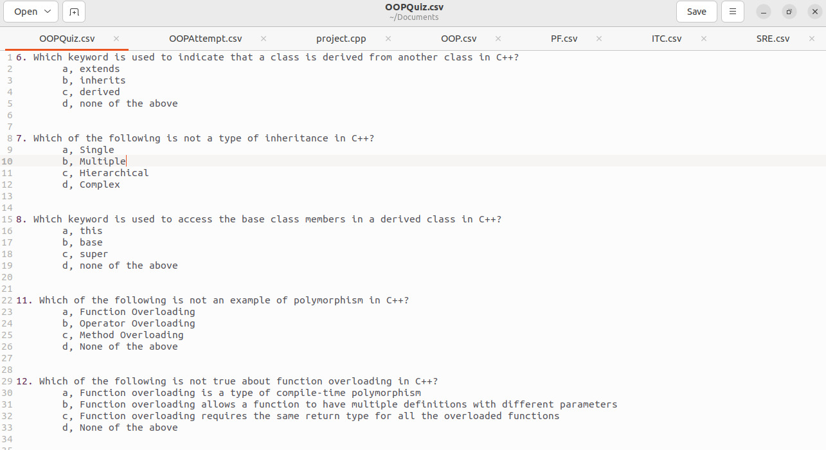

PROCESS BEHIND CASE 2(Teacher):

So the mechanism that happens in the .**cpp** file is that on choosing to login as a student a function **FindTeacher**() is called which reads the **Teacher.csv** file and look for the entered roll no. in it. If it finds the ID in the file it tells that the ID is valid and calls the **getteacherpassword**() and **asktomake**() which checks the validity of the password. If the password is valid it reads the Teacher.csv again and stores the detail(name, ID, courses teaching) and displays them. **asktomake**() function which asks user if they want to make a quiz of their course. If they choose yes then it calls a function **quiz()** of **Quiz class**. The function **quiz()** asks the teacher the no. of topics ( 1 to 4 ) and no. of questions from each topic ( 1 to 5 ) they want to make the quiz from. Then it reads the MCQs of those specific topics from **the Questionbank.csv** file of that course and writes them in a separate file i.e. **Quiz.csv** . So the student can view these questions later.

UPDATED CLASS DIAGRAM:

